Voluntary switching in an invertebrate: the effect of cue and reward change
Tomer J. Czaczkes^{1,3}, Alexandra Koch¹, Kerstin Fröber² and Gesine Dreisbach²
¹ Institute of Zoology, University of Regensburg, Universitätsstraße 31, D-93053 Regensburg, Germany
² Department of Psychology, University of Regensburg, Universitätsstraße, 31, D-93053 Regensburg, Germany
³ Corresponding author, email tomer.czaczkes@ur.de

Word count: 5438

Key words
Voluntary task switching – spontaneous alternation behaviour – flexibility vs. stability – comparative psychology – ants

Funding
TJC was supported by an Emmy Noether group leader grant from the DFG, grant number CZ 237/1-1. KF and GD were supported by a Priority Program SPP 1772 grant from the DFG, grant no. DR 392/8-1.

Abstract
When faced with multiple competing goals, individuals must decide which goal to attend to. Voluntary task switching is an important paradigm for testing cognitive flexibility and spontaneous decision-making when competing tasks are present. Of particular importance is the study of how reward affects task switching, as reward is perhaps the most commonly used tool for shaping both human and animal behaviour. Recently, Fröber & Dreisbach (2016) demonstrated that it is not reward level per se, but reward change, which most strongly affects switching behaviour in humans: Task switching was lowest when reward remained high and highest when reward is changed (increase or decrease), while the repetition of low reward showed intermediate switching levels. Here we replicate their experiment on individual foragers of the ant species Lasius niger. Using an adapted spontaneous alternation task, we find that ants’ switching response in light of their immediate reward history is qualitatively identical to that of humans. In a second experiment, we show that some of this behaviour can be explained by the cue change, rather than the rewards. However, patterns exist in the data which cue change cannot explain. The striking parallel in behaviour between humans and insects raises questions about how reward shapes behavioural flexibility and stability in humans.

Introduction
All organisms are constantly faced with multiple competing short term goals. A researcher at his desk could direct his attention and efforts to answering emails, to writing a manuscript, or to procrastination. An ant in her nest has the option to tend brood, help expand the nest, or to do nothing. In order to decide which goal to pursue, and thus how to behave, humans and other animals must respond flexibly to changing environmental and internal stimuli. In essence, the challenge that both humans and animals face in a dynamic environment is to decide whether to show flexible or stable behaviour. When showing stable behaviour individuals shield their current goal against distraction, thereby allowing exploitation of their current situation, but running the risk of missing out on higher rewards or useful information. Conversely, when behaving flexibly individuals can adjust to changing task demands, goals, and rewards, but run the risk of being distracted or paying large switching costs. The exploration/exploitation trade-off is a major field of research in the behavioural sciences (Aston-Jones & Cohen, 2005; Cohen, McClure, & Angela, 2007), and the flexibility/stability trade-off is a growing field of research in human cognition (Dreisbach & Goschke, 2004; Goschke, 2013; Hommel, 2015). The task switching paradigm (Kiesel et al., 2010; Vandierendonck, Liefooghe, & Verbruggen, 2010), in which subjects switch between two tasks repeatedly, has become the standard tool used to study the balance between (cognitive) stability and flexibility in humans. A robust finding is that during task repetitions, the cognitive system is in a more stable and shielded control mode, whereas on task switches, this shielding has to be relaxed in order to be able to switch (Dreisbach & Wenke, 2011). Such relaxation of shielding brings with it switching costs such as decreased accuracy and increased response times (Dreisbach, 2012; Kiesel et al., 2010; Vandierendonck et al., 2010). However, in the standard task switching paradigm, switching is externally imposed by the experimenter, while in most situations outside the laboratory individuals are free to choose when to switch tasks. In humans, executive control processes are thought to control which goals should be pursued at any given moment, and so which behaviours to perform (Banich, 2009). In ants, behaviours might be triggered by stimuli exceeding an individual threshold (Kang & Theraulaz, 2016). For example, an ant sensing recruitment pheromone above a certain threshold might leave the nest to forage. Studying the act of choosing to switch tasks was considered crucial to understanding both what causes cognitive switching costs, and how individuals make decisions (Rogers & Monsell, 1995; Yeung, 2010; Yeung & Monsell, 2003).
The task switching paradigm was therefore modified to allow voluntary task switching (VTS) (Arrington & Logan, 2004; Arrington, Reiman, Weaver, Grange, & Houghton, 2014). In VTS experiments, participants are presented with the opportunity to freely choose between the two tasks, with the constraint that they should attempt to perform both tasks in a random order (the instruction “like flipping a coin” is often given to participants, e.g. (Arrington & Logan, 2004)). ‘Voluntary’ here is thus meant in the phenomenological sense, in that the subjects are not constrained in their choice. Voluntary task switching suggested itself as a new way of measuring direct cognitive control (Arrington & Logan, 2005). In particular, it would allow an experimental examination of what affects decision-making: are decisions to switch tasks made ‘top-down’ by a volitional, conscious mechanism, or are they made ‘bottom-up’? Initial findings suggested that voluntary task switching was indeed controlled primarily by top-down mechanisms (Arrington & Logan, 2005). However, soon voluntary switching rates (VSR) were found to be affected by unexpected factors, such as a change in the reference stimulus used to answer the question (e.g. whether the reference number subjects were judging changed or not) (Mayr & Bell, 2006), and the influence of between-task interference (performance on a previous task affected task choice on upcoming tasks) (Yeung, 2010), calling the role of top down influence into question.
Recently, an important factor affecting both performance during forced and voluntary switching has been identified: reward level, and more precisely the immediate reward history. The effects of rewards on decision-making are particularly worthy of study, as much of our efforts to shape behaviour in both humans and animals are centred on rewarding desirable behaviour. Increasing rewards seems to improve performance when switching tasks (Kleinsorge & Rinkenauer, 2012; Shen & Chun, 2011), while consistently high rewards improved performance when remaining with the same task (Shen & Chun, 2011). Recently, Fröber and Dreisbach (2016) had participants choose between a number and a letter task (deciding whether a number is smaller or larger than a reference number, deciding whether a letter comes from the beginning or the end of the alphabet). They found that whether or not participants switched or repeated the task on a given trial (number vs. letter) depended on the immediate reward history: The VSR was highest when reward level either increased or decreased from one trial to the next. They also found the lowest VSR when reward remained high and an intermediate VSR when reward remained low (see figure 2C). In terms of the aforementioned flexibility-stability balance, this was interpreted as evidence that unchanged high reward promotes stability whereas reward increases or decreases promote cognitive flexibility.
The majority of animals, like humans, live in a dynamically changing environment, and thus face the same trade-offs between flexibility and stability, or exploration and exploitation. The behavioural rules, and neural mechanisms, underlying cognitive flexibility in vertebrates have been the subject of intense research (Klanker, Feenstra, & Denys, 2013), and non-human vertebrates show some parallels, but also striking differences, to human responses in task-switching paradigms (Baker & Ragozzino, 2014; Leenaars et al., 2012; Richter et al., 2014; Stoet & Snyder, 2003). These parallels may well arise from shared neural mechanisms, namely dopamine circuits in the prefrontal cortex (Durstewitz & Seamans, 2008; Schultz, 2013; Schultz, Dayan, & Montague, 1997), and thus make it difficult to assess whether the similarities in behaviour between humans and non-human vertebrates arise due to a shared evolutionary origin, or represent independent convergence on an advantageous behavioural strategy. Invertebrates, however, do not have a prefrontal cortex, and thus a common ancestor hypothesis for parallel behaviours is unlikely, but cannot be ruled out. Nevertheless, invertebrates also contend with an ever-changing environment, just as vertebrates do.
Social insects, such as bees and ants, are particularly well suited for comparative studies. Social insects are very convenient study organisms as they make repeated visits to food sources, unloading the collected food in the nest and returning for more. This makes training social insects very easy, especially ants which can be studied on a lab bench. Importantly, many social insects have already been shown to have remarkably advanced cognitive abilities, perhaps by virtue of being social (Lihoreau, Latty, & Chittka, 2012). Honey bees have, for example, been shown to be able to learn abstract concepts such as symmetry, sameness vs. difference, and above vs. below (Avarguès-Weber, Dyer, & Giurfa, 2010; Avarguès-Weber & Giurfa, 2013; Giurfa, Eichmann, & Menzel, 1996; Giurfa, Zhang, Jenett, Menzel, & Srinivasan, 2001). Ants and bees can make abstract associations between cues and stored memories (Czaczkes, Schlosser, Heinze, & Witte, 2014; Reinhard, Srinivasan, & Zhang, 2004). Both ants and bees learn food locations and food-odour associations very rapidly (Bitterman, Menzel, Fietz, & Schäfer, 1983; Couvillon & Bitterman, 1993; Czaczkes & Heinze, 2015; Czaczkes et al., 2014), and can respond to making errors or opt out of difficult tasks (Czaczkes & Heinze, 2015; Perry & Barron, 2013a).
The aim of the current work was to test whether and how immediate reward history modulates the flexibility-stability balance, as indicated by voluntary switching behaviour, in the ant Lasius niger. This work was expressly designed as an animal-model analogue of a recent study by Fröber and Dreisbach (2016). However, the aim was not to explore cognitive control in insects, as it is unclear whether insects can be considered to show cognitive control in the same sense as humans do (but see (Nityananda, 2016)). Rather, the study aimed to examine behavioural similarities between ants and humans in terms of stability versus flexibility in a comparable reward environment. This will provide insights into how taxonomically widespread such behavioural strategies are, and thus perhaps how broadly adaptive they are. To do this we used an adapted spontaneous alternation paradigm (Deacon & Rawlins, 2006; Dember & Richman, 2012; Richman, Dember, & Kim, 1986): Many animals, both vertebrates and invertebrates, have been found to spontaneously alternate the arms they visit when traversing a T-maze (Dember & Richman, 2012; Moriyama, Migita, & Mitsuishi, 2016). However, ants tend to display very low switching rates, especially when their visits are rewarded (Dingle, 1962). We thus hypothesised that ants would show a similar pattern of voluntary switching to humans in response to reward magnitude change, but with overall lower voluntary switching rates.

Materials and methods
For increased clarity, an audio-visual methods description is provided in Video Supplement 1, available from https://youtu.be/KIfjwozaSAU.

Study species and maintenance
We used 8 queenless colony fragments of the black garden ant, Lasius niger (Linnaeus), collected in 2016 from eight different colonies on the University of Regensburg campus. Each colony was housed in a plastic box (40×30×20cm) with a layer of plaster on the bottom. Each box contained a circular plaster nest (14cm diameter, 2cm high). Colonies contained c. 1000 workers and small amounts of brood. The ants were fed three times per week with Bhatkar diet, a mixture of egg, agar, honey and vitamins (Bhatkar & Whitcomb, 1970), and supplemented with Drosophila melanogaster fruitflies. Colonies were deprived of food for four days prior to each trial to give high and consistent motivation for foraging and pheromone deposition. Water was provided ad libitum.

Experiment 1: the effect of reward magnitude change on path choice and pheromone deposition - methods

Methods overview
This experiment was designed to test in ants the findings of Fröber and Dreisbach (2016) regarding the effect of reward history on behavioural flexibility and stability. Individual ants were first taught (training phase) that a syrup reward could be found on both ends of a T-maze, and that the odour of the T-maze and visual cues around it predict the quality (0.25M or 1M sucrose) of the syrup reward (see figure 1). Note that such alternations in quality will produce a contrast effect (Flaherty, 1996), making the low reward (0.25M) ‘disappointing’ after receiving a high (1M) reward. After training, a probe was carried out to test whether ants had reliably learned to associate the odour and food quality. Thereafter (test phase), ants were allowed to make seven repeated return visits to the T-maze and drink from either one of the syrup feeders at the ends of the maze – both feeders were available. The quality of the reward was systematically varied between visits, with half of the ants tested on one reward order and the other ants on a different order (see table 1). The T-maze arm choice of the ants was measured on each visit as it was heading towards the food source. Thus, the ants could use the prospect of the upcoming reward magnitude, as signalled by odour and visual cues, to influence their decision to take the same arm as in a previous visit (no switch), or the other arm (switch). This decision is analogous, but not the same as, task choice in voluntary task choice experiments (see below). The number of pheromone depositions performed by each ant was also noted on both the outwards (to food) and return (to nest) legs of each visit. After the training phase was finished, a second probe was carried out to test whether ants still reliably preferentially followed high-reward-associated odour cues.
The key recorded behaviour – switching behaviours – studied here is similar to voluntary task switching in that the ants can freely choose two equally good options. It is also similar in that their choice does not affect their potential reward, and that they are responding to reward prospect, as they are cued to their reward level before making a decision. However, selecting an arm of a T-maze may not be considered a task per se, as one can usually fail a task. In this situation there was no correct answer (both arms are always rewarded), and failure is not really possible for the ants, unless they somehow fail to reach the end of one arm of the maze. For this reason, this experiment is also fundamentally different from an associative learning situation, as subject behaviour has no effect on reward levels, and all choices are equally rewarded.

Training phase - details
An ant colony was connected to a plastic T-maze (stem 12cm long, head 22cm, width 2cm, see figure 1). To force ants to choose only one arm of the T-maze, the maze had a 1cm gap between the centre of the T-maze and one of the arms. A syrup reward, consisting of a drop of coloured and scented sucrose, was placed on acetate feeders at the end of each arm of the T-maze. The sucrose solution was either very sweet (1 molar) or somewhat sweet (0.25 molar). The solutions were scented with 0.005% by volume essential oil (rosemary or lemon), and were coloured using either blue or yellow food colouring (RBV Birkmann GmbH & Co). Lemon-scented sucrose was always coloured yellow, rosemary-scented sucrose was coloured blue. Beyond the end of the T-maze stem, and beyond the end of each arm, a conspicuous visual cue was displayed, which always matched the odour cue presented (figure 1). Within each experimental trial, the scent and colour of the sucrose and visual cue always predicted the sucrose quality (i.e. for half of the tested ants 1M sucrose was always lemon-scented and coloured yellow with a yellow visual cue, and in the other half 1M sucrose was always rosemary scented and coloured blue with a blue visual cue). The T-maze arms and stem were covered in disposable paper overlays scented with the same odour as the sucrose. The paper overlays were impregnated with the appropriate scent by storing them for at least 8 hours in a sealed box containing an open glass petridish containing three drops of essential oil.
Ants were allowed onto the T-maze. The first ant to contact the sucrose feeder was marked with a dot of acrylic paint on its abdomen. All other ants were removed from the maze. The ant was then allowed to drink to satiation, and then allowed to return to the nest, where it unloaded the sucrose load it had collected to its nestmates. While the ant was in the nest, the T-maze setup was changed so that access was now only allowed to the other maze side. All the paper overlays were replaced by fresh overlays, as the presence of trail pheromone reduced pheromone deposition in L. niger (Czaczkes, Grüter, & Ratnieks, 2013). The marked ant was then allowed back onto the apparatus. Again the ant was allowed to drink and again return to the nest. The ant made in total 12 visits during the training phase. The order of training visit treatments is given in table 1. Training always began with visits to a low quality feeder on the left and then the right T-maze arms in visits 1 & 2 respectively, as due to a negative contrast effect (Flaherty, 1996), ants which initially experience a high quality food source are unlikely to accept a low quality food source (Wendt & Czaczkes, in prep). After the 12 training visits a learning probe was carried out to test whether the ants had successfully learned to associate the odour and visual cues with their reward qualities. During the probe visit, no odour cues were presented on the T-maze stem, and no visual cue was presented beyond the T-maze head. On one arm of the T-maze low-quality-associated cues and reward were presented, and high quality reward and cues were presented on the other arm. We noted the initial decision of the ant (as scored by crossing a decision line 4 cm from the T-maze centre), and the final decision (as scored by which sucrose drop was contacted first by the ant). 90% of ants initially chose the high-reward-cued arm, and 92% of ants contacted the high quality food first, demonstrating good overall learning. Thereafter, the testing phase began.

Testing phase - details
During the 8 testing phase visits, access to both arms of the T-maze was given. The quality of the food provided, and the appropriate cues, were varied systematically in one of two orders (order 1 – LHHLLHHL, order 2 – HLLHHLHH, L = low reward, H = high reward, see table 1). Finally, a second probe was carried out, to ensure that the cue/reward association had been maintained throughout the experiment. 96% of ants initially chose the high-reward-cued arm, and 94% of ants contacted the high quality food first. After testing ants were permanently removed from the colony, to prevent pesudoreplication. In total we tested 6 ants from each of the 8 colonies. Each colony was tested once a week.

Data collection
Throughout the experiment we collected decision data and pheromone deposition data. On each visit to the food (except the first visit of the naïve ant) we noted the initial and final arm choice of the ant, as outlined for the probes (see above). Voluntary switch rate (VSR) was assessed by whether ants chose the same maze arm as they did on the previous visit. We also noted the number of pheromone depositions performed on both the head and the stem of the T-maze for all outward (to food) and return (to nest) journeys. Pheromone deposition is a stereotyped behaviour in L. niger (Beckers, Deneubourg, & Goss, 1992, p. 199), see https://www.youtube.com/watch?v=lxgw74SizFY for a video), and is easily countable by eye.

Statistical analysis
Statistical analyses were carried out in R 3.1.0 (R Core Team, 2012) using Generalised Linear Mixed Models (GLMMs) in the LME4 package (Bates et al., 2014). GLMMs were used to allow the inclusion of random effects, namely individual ant ID and colony ID. Following Forstmeier & Schielzeth (2011) we included in the tested models only factors and interactions for which we had a-priori reasons for including. Binomial data (switched or not – VSR data) were modelled using a binomial distribution and logit link function. Count data (number of pheromone depositions) were modelled using a Poisson distribution using a log link function. Model fit was checked using the DHARMa package (Hartig, 2016). The model formulae used for all analyses are provided in the methods supplement S1.

Experiment 1 - results
The raw data for all experiments can be found in data supplement S2. The complete statistical output for all comparisons, including odds ratios estimates and their 95% confidence intervals can be found in results supplement S3.
Voluntary switch rate could be assessed either using the initial decision of the ants (which decision-line the ant first crosses, see figure 1) or the final decision of the ants (which sucrose drop it drinks from first). Considering the initial decision, ants showed lower voluntary switching rates when reward prospect remained constant (either low, or high, see figure 2A). Conversely, ants showed higher voluntary switch rates when the ant was cued that upcoming reward would either be higher or lower than the previous reward. A similar pattern of VSR can be seen in the final decisions of the ants, except that VSR rates are intermediate when the reward environment remains low (see figure 2B). For comparison, the voluntary switching behaviour of humans is shown in panel C (reproduced with permission from Fröber & Dreisbach, (2016)). In the memory probe tests, ants demonstrated that they learned to associate the cues and the food qualities well, showing 90% and 92% choices for the high-quality linked cues in the first probe, as measured by the initial and final decision respectively. In the final probe, ants showed 96% and 94% accuracy for the initial and final decision, respectively.

Pheromone deposition was strongly affected both by travel direction (towards the food or towards the nest) and by the reward environment (see figure 3). Ants deposited consistently more pheromone on the way to the food than on their return to the nest (GLMM, Z > 2.67, P < 0.016, OR = 0.66, 95% CI = 0.49 to 0.90). Ants also deposited more pheromone when the reward environment was high (either remaining high or increasing), and deposited less pheromone when the reward environment was low (Z > 6.0, P < 0.0001, OR of smallest high vs low effect > 3.6, 95% C.I. = 2.324 to 5.29). Results for pheromone deposition behaviour on the T-maze head and stem were qualitatively identical. For brevity, only stem data is shown. The full statistical output for both T-maze head and stem data is presented in results supplement S3.

Experiment 1 – discussion
Experiment 1 had two main findings. Firstly, the (final) voluntary switch rate was modulated by immediate reward history and showed a striking similarity to the human data. That is, the lowest voluntary switch rate (VSR) was found when the reward remained high, and the highest VSR was found when the reward changed. This strongly suggests that the stability-flexibility balance can be modulated by reward. Second, pheromone deposition mirrored the expected reward magnitude in the upcoming trials. This demonstrates that ants anticipate the reward magnitude on their way to the food source. In humans, VSR is not only influenced by the immediate reward history but also by physical task cue changes per se. In order to find out whether such an effect could also be shown for the ants (and might contribute to the effects observed in experiment 1), we ran another study with the same cue changes (from rosemary to lemon) that were, however, always associated with the same amount of reward (no sequential reward changes). If a mere cue change would promote flexibility in the ants too, we should find increased VSR on cue changes and lower VSRs on cue repetitions.

Experiment 2 – the effect of value-independent cue change on path choice and pheromone deposition – methods
In experiment 1 two things are varied during the testing phase visits – the reward magnitude the ants expect and experience, and the visual and odour cues in the environment. Changing environmental cues in itself can cause increased voluntary task switching in humans (Mayr & Bell, 2006) when these cues are required to solve the task at hand. To test whether cue changes alone, independent of reward quality changes, affected voluntary switching rates in the ants, we ran experiment 2. This experiment was run identically to experiment 1, except that while the cues were switched as outlined in experiment 1, only one quality of reward (either unchanged high or unchanged low, respectively) was ever presented (see table S1). The quality of the reward was varied between subjects, with some ants always receiving high quality food, and others always low. In total we tested 3 ants from each of 7 colonies and 2 ants from one colony.

Experiment 2 – results
In this experiment the reward offered in each trial was not changed – only the scent of the reward, and the odour and visual cues presented, were changed. Considering the initial decision of the ants, reward quality had no effect on switching rates (Z = 1.44, P = 0.2, OR = 0.36, 95% C.I. = 0.093 to 1.44). While the interaction between molarity and cue change was not significant (Z = 1.92, P = 0.11) the odds ratios suggested that the interaction was nonetheless important (OR = 3.22, 95% C.I. = 0.98 to 10.62, see post-hoc analysis below). Voluntary switching rates were strongly affected by the change in presented cues, with significantly higher switching rates when the cues changed (Z = 4.25, P < 0.0001, OR = 0.16, 95% C.I. = 0.07 to 0.38). When the final decision of the ants is considered, a similar pattern was seen, with a strong effect of cue change (Z = 4.64, P < 0.0001, OR = 0.47, 95% C.I. = 0.26 to 0.84). However, there was also a significant effect of the interaction between molarity and cue change, with a stronger cue-change effect at high molarities (Z = 2.66, P = 0.015, OR = 0.25, 95% C.I. = 0.15 to 0.41, see figure 4). Post-hoc analysis showed that in the high molarity trials cue change was a strong and significant predictor of voluntary switch rates (Z = 4.64, P < 0.0001, OR = 0.12, 95% C.I. = 0.047 to 0.29), while in the low molarity trials cue change did not significantly predict VSR (Z = 0.99, P = 0.32, OR = 0.66, 95% C.I. = 0.29 to 1.51).
Ants again deposit more pheromone when walking towards the food, both on the stem and on the head of the T maze (Z > 7.15, P < 0.0001, OR = 0.50, 95% C.I. = 0.44 to 0.57). Ants deposit less pheromone to lower reward qualities (Z > -2.5, P < 0.02, OR = 0.45, 95% C.I. = 0.24 to 0.84). However, pheromone deposition is not significantly affected by cue changes (Z < 0.59, P > 0.55, OR = 1.05, 95% C.I. = 0.90 to 1.21), or the interaction between cue change and molarity (Z < 0.173, P > 0.1, OR = 0.89, 95% C.I. = 0.68 to 1.18, see supplemental results S3 for figures).

Experiment 2 – discussion
Experiment 2 showed that a mere cue change (without a change of reward) also modulated the voluntary switching rate in ants. Ants showed higher VSR when cues changed, and lower VSR when cues remained the same. However, taking the reward magnitude into account, this modulation was only found when high reward was at stake whereas the cue change did not affect VSR under a low reward condition. This suggests that under conditions of constant high reward the ants are more sensitive to cue changes. VSR magnitudes in experiment 1, and in the high-reward conditions of experiment 2, are very similar. This latter result at first glance seems to be at odds with the finding from Experiment 1, where unchanged high reward – if anything – reduced the voluntary switch rate. But what should be kept in mind here is the context – in experiment 1 the ants experienced changing rewards over the course of the experiment, while in experiment 2 the ants always experienced the same reward throughout the experiment. Repeated high rewards in the context of a changing environment cause reduced VSR, while repeated high-rewards in a constantly high reward environment increase sensitivity to environmental cue changes. From the task switching literature in humans, there is already evidence that the mere change of a cue switch contributes to the voluntary switch rate (Mayr & Bell, 2006) but cannot entirely explain the increased switch rate when reward increases from one trial to the next (see Experiment 2 and 3 in (Fröber & Dreisbach, 2016)). Thus, the results of Experiment 2 presented here show that this sensitivity to physical cue changes is also present in ants, but only when a high reward is at stake.

General Discussion
The voluntary switching response of ants facing a changing reward environment (experiment 1) is striking in its similarity to the responses of humans in similar situations (Fröber & Dreisbach, 2016) (see figure 2). Surprisingly, ants show a higher overall voluntary switch rate (VSR) than humans, although ants are known to show high sector fidelity, and very robustly return to a rewarding arm of a T-maze, showing very low exploration rates thereafter (Czaczkes & Heinze, 2015; Dingle, 1962). Mere associative learning cannot explain the behaviour of the ants in this experiment, as reward was completely disassociated from the ant’s behaviour.
However, the ants also showed high switching rates in response to changing environmental cues even when the cues were unrelated to a (fixed) high reward level (experiment 2). This is strongly reminiscent of the behaviour of humans described by Mayr and Bell (2006) and Yeung (2010). In both cases, the authors found that when a stimulus was repeated, participants were more likely to repeat their task selection as well. In both of these experiments, however, paying attention to the changing stimulus was critical for correctly solving the task; the correct answer depending on the stimulus presented. In experiment 2 from the current study, while the cues predict food, the change in stimulus could be considered ‘meaningless’: the cues merely served as a background, and had no direct bearing on the correct answer to the questions, since firstly both possible ‘answers’ were correct and secondly the cue was identical for both ‘answers’.
The results of experiment 2 therefore raises the question: was the response of the ants in experiment 1 due to the reward change, or the accompanying change in cues? Two lines of evidence suggest that immediate reward history does play a role in influencing VSR in ants. Firstly, we found significant differences in VSR, as measured by the final decision of ants (figure 2B), in experiment 1 between ‘remain high’ and ‘remain low’ situations – just as in humans (Fröber & Dreisbach, 2016) – even though the reward cue was repeated. Reward levels remaining high thus seem to stabilize behaviour, while increasing rewards promotes flexibility. Secondly, it is noteworthy that ants respond strongly to ‘meaningless’ cue changes in a context of unchanging high reward levels (by increasing switching rates), but barely and non-significantly respond to cue changes when rewards are constantly low. We thus argue that, even in ants, rewards and immediate reward history exert an influence on behavioural flexibility and stability. Nonetheless, it is difficult to fully disentangle the effect of cue and reward changes in experiment 1 from the data available, especially as the magnitude of VSR differences between experiment 1 and the high-reward situation in experiment 2 were so similar. Both cue change and reward magnitude change play a role in affecting switching behaviour.
More broadly, it is worth asking why humans (and animals) should choose a potentially costly change of action in response to a meaningless cue change in the first place. A closer look at the results of experiment 2 might provide the answer to this seemingly irrational behaviour. There it was found that the “meaningless” cue change only affected switching rates in a context of consistently high reward levels. This may be linked to the idea that it is the reward context itself that makes organisms sensitive to cue change, because cue changes (in a natural context) might in fact signal changes in reward. This also seems reasonable from an evolutionary perspective, because the ability to extract information about changes in reward from the environment will be advantageous. Cue change might then drive exploration behaviour.
The pheromone deposition of ants on their way to the food source in experiment 1 is very informative. Ants deposited more pheromone when heading towards high-quality food sources, even if on their previous visit they had found a low quality food source, and vice versa for low quality food (see figure 3). This demonstrates that the ants could well anticipate the quality of the food they were approaching. No parallel pattern of pheromone deposition, with increased deposition to one odour and decreased deposition to the other, can be seen in experiment 2, demonstrating that the pheromone deposition behaviour responds only to food quality changes, not cue changes. The results of the probes in experiment 1 also demonstrate that the ants were well able to learn the cue / quality association and act upon it.
An interesting parallel in the study of human and animal cognition is the parallel between voluntary task switching and the spontaneous alternation behaviour (SAB). The SAB paradigm is a classic technique in the study of animal behaviour and cognition (Deacon & Rawlins, 2006). Spontaneous alternation behaviour has been extensively studied since the start of the 20th century (Hunter, 1914; Richman et al., 1986), and continues to be a mainstay for the study of untrained memory use, amongst other uses (Dember & Richman, 2012). In principle, it studies the same behaviour as voluntary task switching in human experiments – whether a subject chooses to repeat an action, or to try a different action. It is, however, noteworthy that in the otherwise excellent review of voluntary tasks switching by Arrington et al. (2014) there is no mention of SAB. We suggest that there may be a wealth of knowledge and inspiration hiding in plain sight for researchers interested in VTS, requiring only a cursory delve into the SAB literature, and vice versa for researchers studying SAB.
Also very relevant to the results of this study, and to the effect of reward change on behaviour, is the concept of relative value perception, and specifically of incentive contrasts (Flaherty, 1996). This describes a situation in which the response to a fixed quality reward is strongly affected by the preceding experience of the subject. For example, under negative incentive contrast, subjects which previously experienced a high reward undervalue medium rewards compared to control subjects which only had previous experience with medium rewards. This can loosely be considered disappointment. This pattern is well documented in humans (Kahneman & Tversky, 1979), other vertebrates (Flaherty, 1996), and also in bees (Bitterman, 1976; Townsend-Mehler, Dyer, & Maida, 2010; Waldron, Wiegmann, & Wiegmann, 2005) and ants (Wendt & Czaczkes, in prep). The reverse, positive incentive contrast, has less clear evidence in non-human animals, but has also been demonstrated in vertebrates (Flaherty, 1996; Olton & Schlosberg, 1978; Rayburn-Reeves, Laude, & Zentall, 2013) and in ants (Wendt & Czaczkes, in prep). The ecological value of incentive contrasts, and the evolutionary pressures shaping this behaviour, are beginning to be understood (McNamara, Fawcett, & Houston, 2013). In voluntary task switching experiments such as the current study, the subjects undergo incentive contrasts both during training and testing. Whether a reward is considered high or low is to a great extent a function of its contrast with the other rewards. By framing the effects of reward change on VTS in terms of incentive contrasts, we might begin to understand the evolutionary pressures underlying the behaviour patterns of the ants in this study, as well as of the humans in previous studies. However, as in humans (Teodorescu, Moran, & Usher, 2016), the absolute value of the reward also affects the behaviour of ants, as can be seen in experiment 2. While even the low reward level is well within the detection and acceptance thresholds of the ants (Detrain & Prieur, 2014), the response of the ants is quite different depending on the absolute quality of the reward. It is likely, however, that the ants were also comparing the reward to their normal diet, which has a sweetness intermediate between the high and low rewards in this experiment. In this context, it is worth asking whether absolute reward levels affect VTS rates in humans as well.
Finally, we must ask what can be learned about human voluntary task switching behaviour from our results on switching behaviour in ants? The behaviour of the ants in this study and the humans in Fröber and Dreisbach (2016) were extremely similar, with the ants showing more pronounced changes in switching rates than humans. While there are striking similarities in the neural mechanisms underlying reward in mammals and insects (Perry & Barron, 2013b), the brains of ants and humans are very different, strongly implying that any similarities in behaviour represent convergent evolution rather than shared ancestry. By extension, this implies that increasing (cognitive) flexibility when rewards are increasing or decreasing, and strengthening (cognitive) stability when rewards remain high, is a beneficial trait. This makes intuitive sense (begin exploring other options when the environment changes, and if something is providing good rewards, do not stop doing it), and is in line with our current understanding of near-optimal behaviour in risky situations and when trading-off exploration and exploitation (Mehlhorn et al., 2015). While finding an optimal solution to the exploration-exploitation trade-off is proving elusive, and may be impossible (Cohen et al., 2007), a rule of thumb such as “change behaviour when reward levels change” may represent an effective and simple heuristic to achieve good results under a wide range of situations. As discussed above, this also makes evolutionary sense when seen in the context of incentive contrasts (McNamara et al., 2013). In terms of concrete benefits for the ants, changing honeydew or nectar quality from a known source implies some change in the environment has occurred, meaning that perhaps better options are now available for exploitation. Ant foragers can simultaneously learn the location of at least two separate food sources and cues associated with them (Czaczkes et al., 2014). Several cues associated with flowers can predict nectar flow (von Arx, 2013), and so responding to such quality-related cue changes by increased flexibility may increase nectar collection rates by ants and other insects.
Voluntary task switching experiments have been used to examine the role of top-down versus bottom-up processes in human decision-making (Arrington & Logan, 2005; Arrington et al., 2014; Yeung, 2010). Most psychologists (including the last author of this article) would be reluctant to ascribe top-down executive control to an animal with a brain smaller than the head of a pin (but see Klein, Barron, & others, 2016; Nityananda, 2016). Assuming that ants are not capable of top-down executive control, our results suggest that at least some of the ways in which humans behave in VTS tasks can be fully explained without top-down executive control decision-making. This does not, of course, imply that human VTS behaviour must be bottom-up. Indeed, the idea of a strict differentiation between bottom up and top down control has been relaxed (Posner & Snyder, 1975; Shiffrin & Schneider, 1977), as it was acknowledged that controlled processes (classically top-down) can be automatically triggered (bottom up), and control sets (such as attentional sets, classically top-down) can automatically (bottom-up) be retrieved from memory (e.g. Bugg & Crump, 2012; Egner, 2008). Some have suggested that mechanistic associations could be the building blocks of propositions: propositions and automatic associations may simply reflect different levels of analysis, analogous to the relationship of physics to chemistry and chemistry to biology (Le Pelley, Griffiths, & Beesley, 2017, but see De Houwer, Hughes, & Barnes-Holmes, 2016).
Broadly speaking, when humans and animals are seen to respond in a similar way to similar treatments, two mechanistic explanations are possible. Either the behaviour of the two groups is the same, but the mechanisms leading to this behaviour are different. Alternatively, both groups are performing the same behaviour due to similar mechanisms. Occam’s razor favours the latter explanation, but Occam’s Razor is a notoriously blunt instrument. After all, insects and humans do not share a common neural architecture, so the physiological mechanisms must be different. Nonetheless, different neural architectures could produce the same cognitive mechanisms, for example simple heuristics which both systems follow. If the similar behaviours of humans and animals both stem from similar cognitive mechanisms, two further possibilities arise: Either the animals have advanced cognitive control very similar to that of humans, or the apparently advanced processes shaping human behaviour are a veneer over a more basic system. Which of these possibilities holds true, for VTS or more broadly, cannot be ascertained from the data we present in this study. Answers to such questions remain an elusive goal for comparative psychologists. Limiting ourselves to the behaviours in the current study, it seems that humans and ants evolved similar surface responses to changing reward, likely due to similar evolutionary pressures, using different neuronal architecture, but with perhaps similar cognitive mechanism.

Author contributions
TJC conceived of the study, performed the statistical analysis, coordinated the study, and wrote the manuscript. AK carried out all data collection. TJC, AK, KF and GD designed the study. All authors contributed intellectually to the manuscript, and gave final approval for publication.

References
Arrington, C. M., & Logan, G. D. (2004). The Cost of a Voluntary Task Switch. Psychological Science, 15(9), 610–615. https://doi.org/10.1111/j.0956-7976.2004.00728.x
Arrington, C. M., & Logan, G. D. (2005). Voluntary task switching: chasing the elusive homunculus. Journal of Experimental Psychology: Learning, Memory, and Cognition, 31(4), 683.
Arrington, C. M., Reiman, K. M., Weaver, S. M., Grange, J., & Houghton, G. (2014). Voluntary task switching. Task Switching, 117–136.
Aston-Jones, G., & Cohen, J. D. (2005). An integrative theory of locus coeruleus-norepinepherine function: Adaptive Gain and Optimal Performance. Annual Review of Neuroscience, 28(1), 403–450. https://doi.org/10.1146/annurev.neuro.28.061604.135709
Avarguès-Weber, A., Dyer, A. G., & Giurfa, M. (2010). Conceptualization of above and below relationships by an insect. Proceedings of the Royal Society of London B: Biological Sciences, rspb20101891. https://doi.org/10.1098/rspb.2010.1891
Avarguès-Weber, A., & Giurfa, M. (2013). Conceptual learning by miniature brains. Proceedings of the Royal Society B: Biological Sciences, 280(1772), 20131907. https://doi.org/10.1098/rspb.2013.1907
Baker, P. M., & Ragozzino, M. E. (2014). Contralateral disconnection of the rat prelimbic cortex and dorsomedial striatum impairs cue-guided behavioral switching. Learning & Memory, 21(8), 368–379. https://doi.org/10.1101/lm.034819.114
Banich, M. T. (2009). Executive Function: The Search for an Integrated Account. Current Directions in Psychological Science, 18(2), 89–94. https://doi.org/10.1111/j.1467-8721.2009.01615.x
Bates, D., Maechler, M., Bolker, B., Walker, S., Christensen, R. H. B., & Singmann, H. (2014). lme4: Linear mixed-effects models using Eigen and S4 (Version 1.1-5). Retrieved from http://cran.r-project.org/web/packages/lme4/index.html
Beckers, R., Deneubourg, J., & Goss, S. (1992). Trail laying behaviour during food recruitment in the ant Lasius niger (L.). Insectes Sociaux, 39, 59–71.
Bhatkar, A., & Whitcomb, W. H. (1970). Artificial diet for rearing various species of ants. The Florida Entomologist, 53(4), 229–232.
Bitterman, M. E. (1976). Incentive contrast in honey bees. Science, 192(4237), 380–382.
Bitterman, M. E., Menzel, R., Fietz, A., & Schäfer, S. (1983). Classical conditioning of proboscis extension in honeybees Apis mellifera). Journal of Comparative Psychology, 97(2), 107.
Bugg, J. M., & Crump, M. J. C. (2012). In Support of a Distinction between Voluntary and Stimulus-Driven Control: A Review of the Literature on Proportion Congruent Effects. Frontiers in Psychology, 3. https://doi.org/10.3389/fpsyg.2012.00367
Cohen, J. D., McClure, S. M., & Angela, J. Y. (2007). Should I stay or should I go? How the human brain manages the trade-off between exploitation and exploration. Philosophical Transactions of the Royal Society of London B: Biological Sciences, 362(1481), 933–942.
Couvillon, P. A., & Bitterman, M. E. (1993). Learning in honeybees as a function of amount of reward: Further experiments with color. Animal Learning & Behavior, 21(1), 23–28.
Czaczkes, T. J., Grüter, C., & Ratnieks, F. L. W. (2013). Ant foraging on complex trails: route learning and the role of trail pheromones in Lasius niger. The Journal of Experimental Biology, 216, 188–197. https://doi.org/10.1242/​jeb.076570
Czaczkes, T. J., & Heinze, J. (2015). Ants adjust their pheromone deposition to a changing environment and their probability of making errors. Proceedings of the Royal Society B-Biological Sciences, 282(1810), 20150679. https://doi.org/10.1098/rspb.2015.0679
Czaczkes, T. J., Schlosser, L., Heinze, J., & Witte, V. (2014). Ants use directionless odour cues to recall odour-associated locations. Behavioral Ecology and Sociobiology, 68(6), 981–988. https://doi.org/10.1007/s00265-014-1710-2
De Houwer, J., Hughes, S., & Barnes-Holmes, D. (2016). Associative learning as higher order cognition: Learning in human and nonhuman animals from the perspective of propositional theories and relational frame theory. Journal of Comparative Psychology, 130(3), 215.
Deacon, R. M. J., & Rawlins, J. N. P. (2006). T-maze alternation in the rodent. Nature Protocols, 1(1), 7–12. https://doi.org/10.1038/nprot.2006.2
Dember, W. N., & Richman, C. L. (2012). Spontaneous Alternation Behavior. Springer Science & Business Media.
Detrain, C., & Prieur, J. (2014). Sensitivity and feeding efficiency of the black garden ant Lasius niger to sugar resources. Journal of Insect Physiology, 64, 74–80. https://doi.org/10.1016/j.jinsphys.2014.03.010
Dingle, H. (1962). The occurrence of correcting behavior in various insects. Ecology, 43(4), 727–728.
Dreisbach, G. (2012). Mechanisms of Cognitive Control: The Functional Role of Task Rules. Current Directions in Psychological Science, 21(4), 227–231. https://doi.org/10.1177/0963721412449830
Dreisbach, G., & Goschke, T. (2004). How Positive Affect Modulates Cognitive Control: Reduced Perseveration at the Cost of Increased Distractibility. Journal of Experimental Psychology: Learning, Memory, and Cognition, 30(2), 343–353. https://doi.org/10.1037/0278-7393.30.2.343
Dreisbach, G., & Wenke, D. (2011). The shielding function of task sets and its relaxation during task switching. Journal of Experimental Psychology: Learning, Memory, and Cognition, 37(6), 1540.
Durstewitz, D., & Seamans, J. K. (2008). The Dual-State Theory of Prefrontal Cortex Dopamine Function with Relevance to Catechol-O-Methyltransferase Genotypes and Schizophrenia. Biological Psychiatry, 64(9), 739–749. https://doi.org/10.1016/j.biopsych.2008.05.015
Egner, T. (2008). Multiple conflict-driven control mechanisms in the human brain. Trends in Cognitive Sciences, 12(10), 374–380.
Flaherty, C. F. (1996). Incentive relativity. Problems in the behavioural sciences, vol. 13. New York, NY: Cambridge University Press.
Forstmeier, W., & Schielzeth, H. (2011). Cryptic multiple hypotheses testing in linear models: overestimated effect sizes and the winner’s curse. Behavioral Ecology and Sociobiology, 65(1), 47–55. https://doi.org/10.1007/s00265-010-1038-5
Fröber, K., & Dreisbach, G. (2016). How sequential changes in reward magnitude modulate cognitive flexibility: Evidence from voluntary task switching. Journal of Experimental Psychology: Learning, Memory, and Cognition, 42(2), 285–295. https://doi.org/10.1037/xlm0000166
Giurfa, M., Eichmann, B., & Menzel, R. (1996). Symmetry perception in an insect. Nature, 382(6590), 458–461. https://doi.org/10.1038/382458a0
Giurfa, M., Zhang, S., Jenett, A., Menzel, R., & Srinivasan, M. V. (2001). The concepts of ‘sameness’ and ‘difference’ in an insect. Nature, 410(6831), 930–933. https://doi.org/10.1038/35073582
Goschke, T. (2013). Volition in action: intentions, control dilemmas and the dynamic regulation of intentional control. Action Science: Foundations of an Emerging Discipline. MIT Press, Cambridge, MA, 409–434.
Hartig, F. (2016). DHARMa - Residual Diagnostics for HierArchical (Multi-level / Mixed) Regression Models. R package Version 0.1.3. Retrieved 18 December 2016, from https://CRAN.R-project.org/package=DHARMa
Hommel, B. (2015). Between persistence and flexibility: The Yin and Yang of action control. Advances in Motivation Science, 2, 33–67.
Hunter, W. S. (1914). The auditory sensitivity of the white rat. Journal of Animal Behavior, 4(3), 215–222. https://doi.org/10.1037/h0072405
Kahneman, D., & Tversky, A. (1979). Prospect Theory: An Analysis of Decision under Risk. Econometrica, 47(2), 263. https://doi.org/10.2307/1914185
Kang, Y., & Theraulaz, G. (2016). Dynamical Models of Task Organization in Social Insect Colonies. Bulletin of Mathematical Biology, 78(5), 879–915. https://doi.org/10.1007/s11538-016-0165-1
Kiesel, A., Steinhauser, M., Wendt, M., Falkenstein, M., Jost, K., Philipp, A. M., & Koch, I. (2010). Control and interference in task switching—A review. Psychological Bulletin, 136(5), 849.
Klanker, M., Feenstra, M., & Denys, D. (2013). Dopaminergic control of cognitive flexibility in humans and animals. Frontiers in Neuroscience, 7. https://doi.org/10.3389/fnins.2013.00201
Klein, C., Barron, A. B., & others. (2016). Insects have the capacity for subjective experience. Retrieved from https://www.researchonline.mq.edu.au/vital/access/services/Download/mq:44848/DS01
Kleinsorge, T., & Rinkenauer, G. (2012). Effects of Monetary Incentives on Task Switching. Experimental Psychology, 59(4), 216–226. https://doi.org/10.1027/1618-3169/a000146
Le Pelley, M. E., Griffiths, O., & Beesley, T. (2017). Associative accounts of causal cognition. In The Oxford Handbook of Causal Reasoning (Michael Waldmann (Eds), pp. 13–28). New York: Oxford University Press.
Leenaars, C. H. C., Joosten, R. N. J. M. A., Zwart, A., Sandberg, H., Ruimschotel, E., Hanegraaf, M. A. J., … van Someren, E. J. W. (2012). Switch-task performance in rats is disturbed by 12 h of sleep deprivation but not by 12 h of sleep fragmentation. Sleep, 35(2), 211–221. https://doi.org/10.5665/sleep.1624
Lihoreau, M., Latty, T., & Chittka, L. (2012). An Exploration of the Social Brain Hypothesis in Insects. Frontiers in Physiology, 3. https://doi.org/10.3389/fphys.2012.00442
Mayr, U., & Bell, T. (2006). On how to be unpredictable evidence from the voluntary task-switching paradigm. Psychological Science, 17(9), 774–780.
McNamara, J. M., Fawcett, T. W., & Houston, A. I. (2013). An Adaptive Response to Uncertainty Generates Positive and Negative Contrast Effects. Science, 340(6136), 1084–1086. https://doi.org/10.1126/science.1230599
Mehlhorn, K., Newell, B. R., Todd, P. M., Lee, M. D., Morgan, K., Braithwaite, V. A., … Gonzalez, C. (2015). Unpacking the exploration–exploitation tradeoff: A synthesis of human and animal literatures. Decision, 2(3), 191–215. https://doi.org/10.1037/dec0000033
Moriyama, T., Migita, M., & Mitsuishi, M. (2016). Self-corrective behavior for turn alternation in pill bugs (Armadillidium vulgare). Behavioural Processes, 122, 98–103. https://doi.org/10.1016/j.beproc.2015.11.016
Nityananda, V. (2016). Attention-like processes in insects. Proc. R. Soc. B, 283(1842), 20161986. https://doi.org/10.1098/rspb.2016.1986
Olton, D. S., & Schlosberg, P. (1978). Food-searching strategies in young rats: Win-shift predominates over win-stay. Journal of Comparative and Physiological Psychology, 92(4), 609–618. https://doi.org/10.1037/h0077492
Perry, C. J., & Barron, A. B. (2013a). Honey bees selectively avoid difficult choices. Proceedings of the National Academy of Sciences, 110(47), 19155–19159. https://doi.org/10.1073/pnas.1314571110
Perry, C. J., & Barron, A. B. (2013b). Neural Mechanisms of Reward in Insects. Annual Review of Entomology, 58(1), 543–562. https://doi.org/10.1146/annurev-ento-120811-153631
Posner, M. I., & Snyder, C. R. R. (1975). Attention and cognitive control. In Information processing and cognition (Solso R. L. (Eds.), pp. 55–85). Hillsdale: Erlbaum.
R Core Team. (2012). R: A Language and Environment for Statistical Computing. Vienna, Austria: R Foundation for Statistical Computing. Retrieved from http://www.R-project.org
Rayburn-Reeves, R. M., Laude, J. R., & Zentall, T. R. (2013). Pigeons show near-optimal win-stay/lose-shift performance on a simultaneous-discrimination, midsession reversal task with short intertrial intervals. Behavioural Processes, 92, 65–70. https://doi.org/10.1016/j.beproc.2012.10.011
Reinhard, J., Srinivasan, M. V., & Zhang, S. (2004). Olfaction: Scent-triggered navigation in honeybees. Nature, 427(6973), 411–411. https://doi.org/10.1038/427411a
Richman, C. L., Dember, W. N., & Kim, P. (1986). Spontaneous alternation behavior in animals: A review. Current Psychology, 5(4), 358–391. https://doi.org/10.1007/BF02686603
Richter, S. H., Vogel, A. S., Ueltzhöffer, K., Muzzillo, C., Vogt, M. A., Lankisch, K., … Vollmayr, B. (2014). Touchscreen-paradigm for mice reveals cross-species evidence for an antagonistic relationship of cognitive flexibility and stability. Frontiers in Behavioral Neuroscience, 8. https://doi.org/10.3389/fnbeh.2014.00154
Rogers, R. D., & Monsell, S. (1995). Costs of a predictable switch between simple cognitive tasks. Journal of Experimental Psychology: General, 124(2), 207.
Schultz, W. (2013). Updating dopamine reward signals. Current Opinion in Neurobiology, 23(2), 229–238. https://doi.org/10.1016/j.conb.2012.11.012
Schultz, W., Dayan, P., & Montague, P. R. (1997). A Neural Substrate of Prediction and Reward. Science, 275(5306), 1593–1599. https://doi.org/10.1126/science.275.5306.1593
Shen, Y. J., & Chun, M. M. (2011). Increases in rewards promote flexible behavior. Attention, Perception, & Psychophysics, 73(3), 938–952.
Shiffrin, R. M., & Schneider, W. (1977). Controlled and automatic human information processing: II. Perceptual learning, automatic attending and a general theory. Psychological Review, 84(2), 127.
Stoet, G., & Snyder, L. H. (2003). Executive control and task-switching in monkeys. Neuropsychologia, 41(10), 1357–1364. https://doi.org/10.1016/S0028-3932(03)00048-4
Teodorescu, A. R., Moran, R., & Usher, M. (2016). Absolutely relative or relatively absolute: violations of value invariance in human decision making. Psychonomic Bulletin & Review, 23(1), 22–38. https://doi.org/10.3758/s13423-015-0858-8
Townsend-Mehler, J. M., Dyer, F. C., & Maida, K. (2010). Deciding when to explore and when to persist: a comparison of honeybees and bumblebees in their response to downshifts in reward. Behavioral Ecology and Sociobiology, 65(2), 305–312. https://doi.org/10.1007/s00265-010-1047-4
Vandierendonck, A., Liefooghe, B., & Verbruggen, F. (2010). Task switching: Interplay of reconfiguration and interference control. Psychological Bulletin, 136(4), 601–626. https://doi.org/10.1037/a0019791
von Arx, M. (2013). Floral humidity and other indicators of energy rewards in pollination biology. Communicative & Integrative Biology, 6(1), e22750.
Waldron, F. A., Wiegmann, D. D., & Wiegmann, D. A. (2005). Negative Incentive Contrast Induces Economic Choice Behavior by Bumble Bees. International Journal of Comparative Psychology, 18(4). Retrieved from http://escholarship.org/uc/item/5w82004f
Yeung, N. (2010). Bottom-up influences on voluntary task switching: The elusive homunculus escapes. Journal of Experimental Psychology: Learning, Memory, and Cognition, 36(2), 348–362. https://doi.org/10.1037/a0017894
Yeung, N., & Monsell, S. (2003). Switching between tasks of unequal familiarity: the role of stimulus-attribute and response-set selection. Journal of Experimental Psychology: Human Perception and Performance, 29(2), 455.

Figures and tables
Visit | treatment | Reward / reward location
1 | Training | Low / left
2 | Training | Low / right
3 | Training | High / left
4 | Training | High / right
5 | Training | Low / left
6 | Training | High / right
7 | Training | Low / right
8 | Training | High / left
9 | Training | Low / left
10 | Training | High / right
11 | Training | Low / right
12 | Training | High / left
13 | Probe 1 | Low / left & high / right *
 |  | Order 1 | Quality change | Order 2 | Quality change
14 | Test | Low / both | NA | High / both | NA
15 | Test | High / both | Increase | Low / both | Decrease
16 | Test | High / both | Remain high | Low / both | Remain low
17 | Test | Low / both | Decrease | High / both | Increase
18 | Test | Low / both | Remain low | High / both | Remain high
19 | Test | High / both | Increase | Low / both | Decrease
20 | Test | High / both | Remain high | High / both | Increase
21 | Test | Low / both | decrease | High / both | Remain high
22 | Probe 2 | Low / left & high / right *

Table 1 – treatment orders for experiment 1. The first 12 visits are training visits, in which the ants are taught that both food qualities can appear on both sides of the T-maze. The ants also learn to associate the odour and visual cues with the quality of the reward offered. Low reward is 0.25 molar sucrose. High reward is 1.0 molar sucrose. The side (left or right) refers to the location of the reward. In the training visits, where the reward is only offered on one arm of the T-maze, access to the other arm is blocked. In probe trials, one arm offered high reward and the associated cues, and the other side low-quality rewards and associated cues. *Half of all probes were performed with the side order as shown in this table. The other trials were performed with the sides reversed.

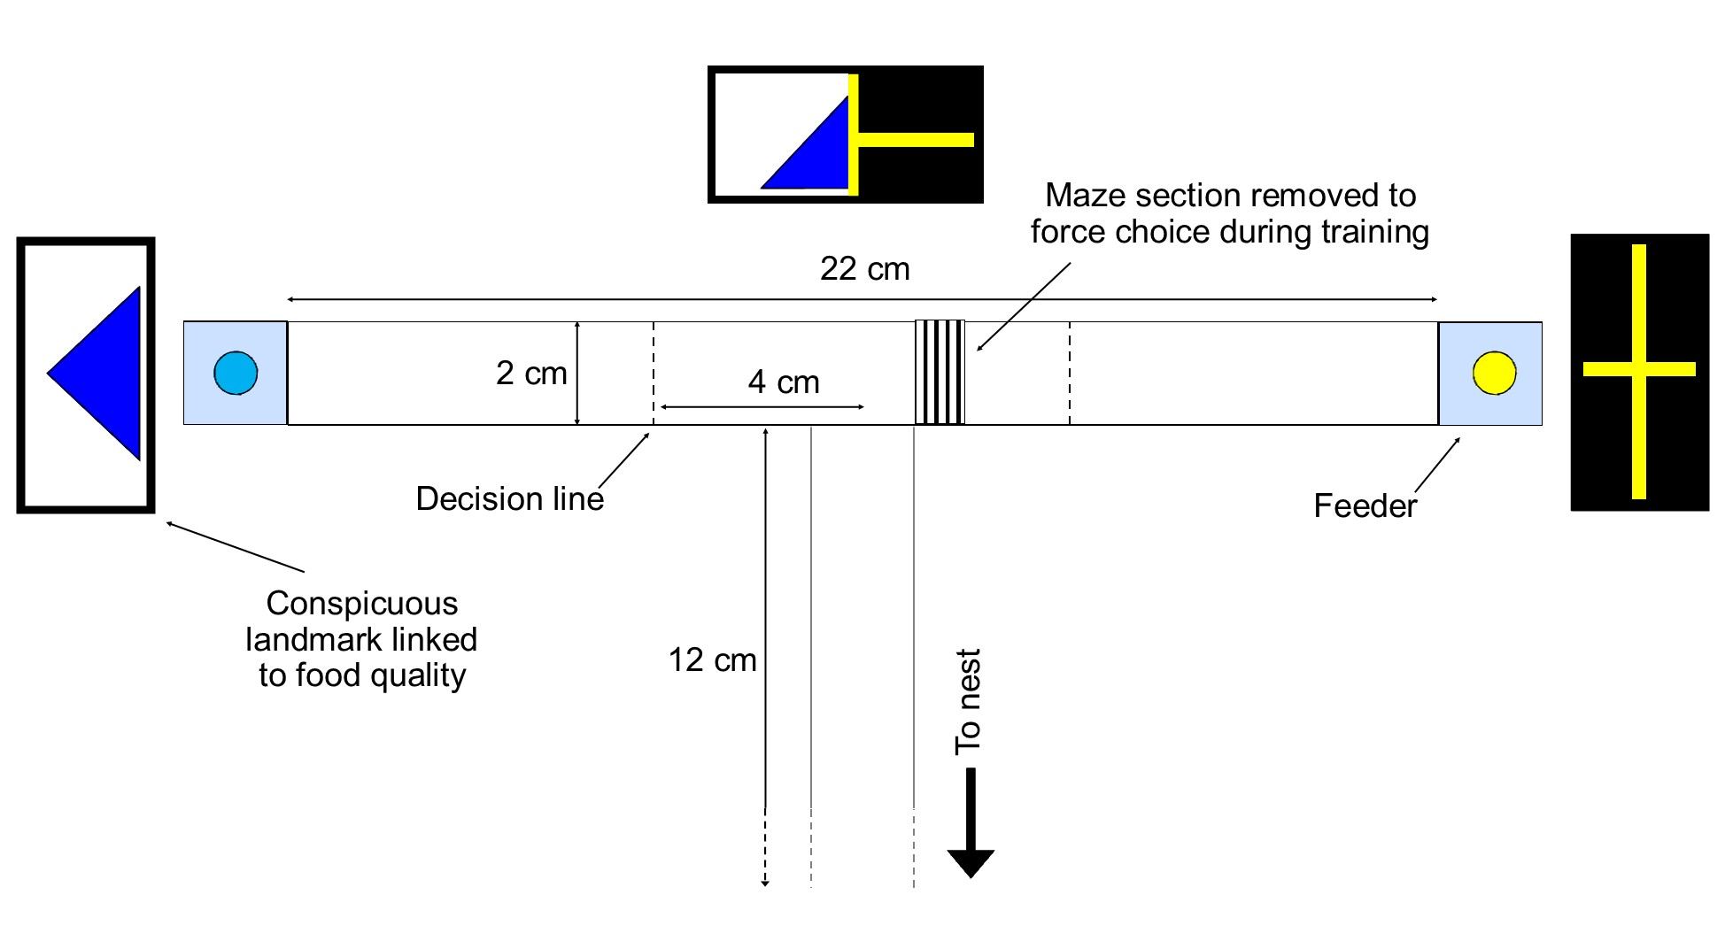
Figure 1 – Experimental setup. The quality of the sucrose solution (0.25M or 1M) was cued by scenting the paper overlays covering the plastic T-maze (rosemary or lemon), by the colour and odour of the sucrose solution (lemon and yellow or rosemary and blue), and by conspicuous visual landmarks just past the end of the bifurcation point, and just past the end of each arm (a blue triangle or a yellow cross).. Lemon scents were always paired with yellow visual cues and vice versa, but for half of the tested ants lemon/yellow predicted high quality, and for the other half low quality. During the training and testing phase, only one odour/visual cue set was present during each visit – the mixed situation shown in the figure is for illustration purposes. The central visual cue rectangle represents either the yellow or the blue cue; the mixed cue is for illustration purposes only. During learning probes one arm displayed one set of cues and the other arm the other, while the central visual cue was removed. During the training phase a 1cm segment of one of the maze arms was removed, to force ants to choose the other arm. For a video illustration of the methods, see Supplementary video 1.

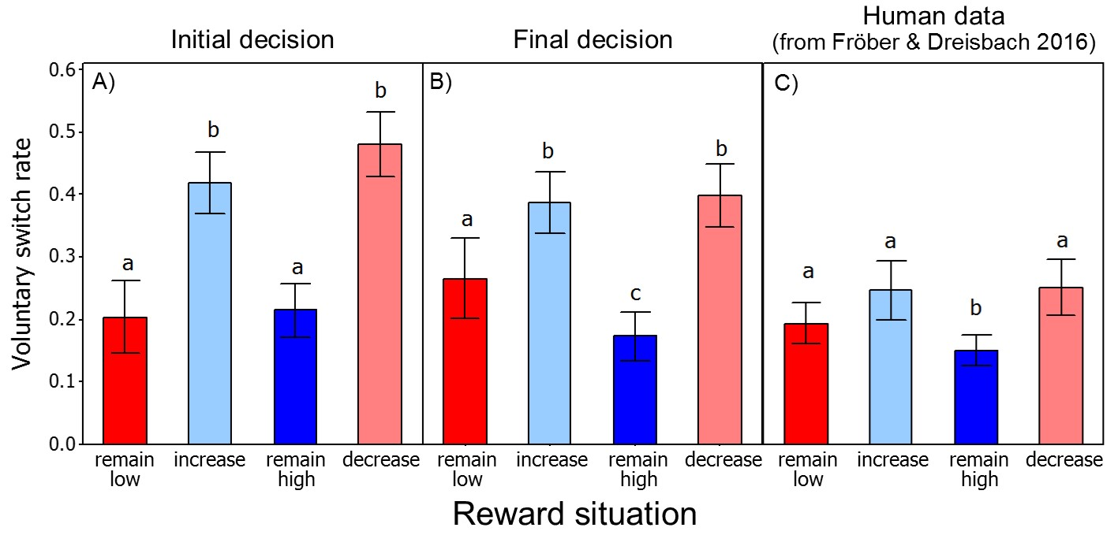
Figure 2 – Experiment 1 Voluntary switch rates. The initial decision (A) refers to data about which decision-line the ant crosses first. The final decision (B) refers to data about which food source is sampled first. Panel C shows VSR data on humans, reproduced with permission from Fröber and Dreisbach (2016). Bars indicate means, whiskers indicate 1 standard error. Different small-case letters indicate significant differences between groups (GLMM, P < 0.05). In (A) and (B) sample sizes are 49 in ‘remain low’ and 98 for the other groups. Each sample is an individual ant decision, with multiple decisions per ant. Difference comparisons were only performed within data set, i.e. the letters cannot be used to compare data between panels.

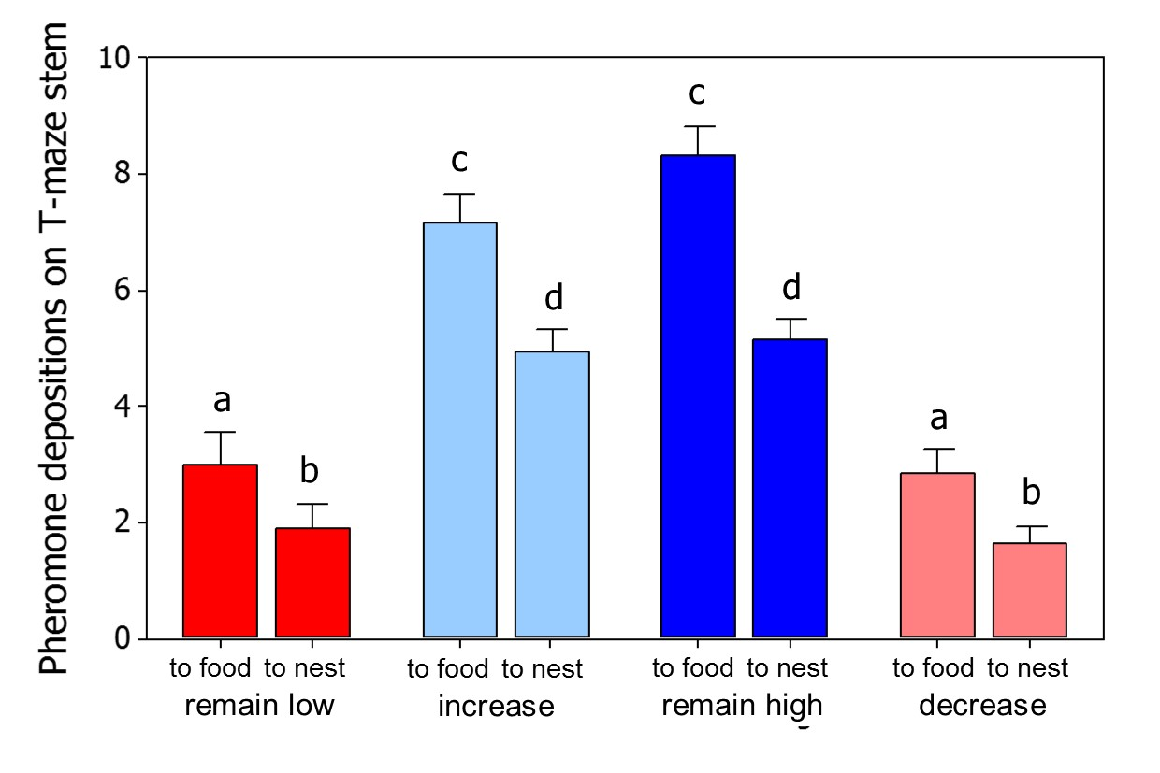
Figure 3 – Experiment 1 pheromone depositions. Ants deposited more pheromone when travelling towards the food, and less on their return to the nest. Ants deposited more pheromone when they were offered a high reward, and less when offered a low reward. As can be seen from the ‘to food’ data, ants anticipate the reward they were about to receive, and adjusted their pheromone deposition accordingly. Bars are means, whiskers are 1 standard deviation. Different letters represent significant differences between groups. Groups headed by different letters are significantly different (GLMM, P < 0.05).
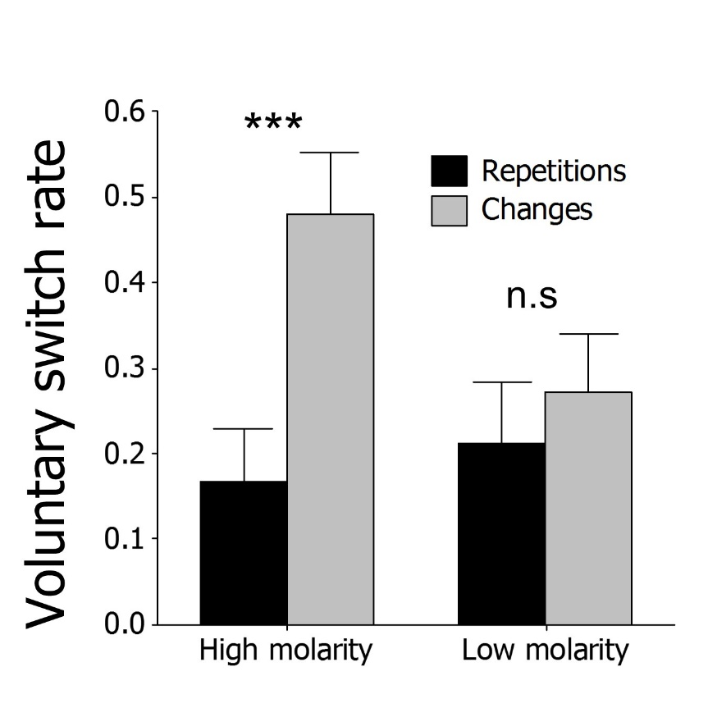
Figure 4 – Experiment 2 Voluntary switch rates. When rewards are high (1 molar sucrose), ants show higher VSR rates when the reward quality remains constant but the cue environment changes. When rewards are low (0.25 molar sucrose) the trend is similar but non-significant. Bars are means, whiskers are 1 standard deviation.

